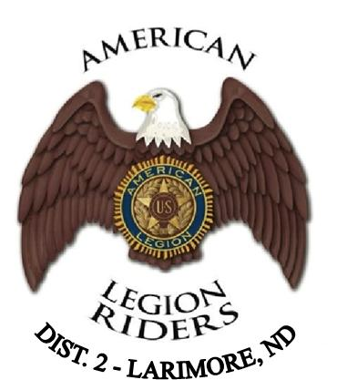

AMERICAN LEGION RIDERS, ND DISTRICT #2
SCHOLARSHIP APPLICATION

Fund Background: Established in 2018 by the District #2 American Legion Riders to provide financial assistance to graduating seniors who plan to pursue post-secondary vocational education. Students graduating from the following high schools are eligible to apply: Larimore, Park River, Midway, Northwood, Grafton, Dakota Prairie, Fordville, Valley-Edinburg, and Minto.

American Legion Riders chapters are well known for their charitable work, which has raised hundreds of thousands of dollars for local children’s hospitals, schools, veterans’ homes, severely wounded servicemembers, and scholarships. Since 2006, Riders nationwide have participated in The American Legion Legacy Run to annually raise money for the Legacy Scholarship Fund, established to provide scholarships to children of U.S. military personnel killed since Sept. 11, 2001.

Eligibility Requirements:

- Graduating high school seniors,
- Descendants of a Military Veteran (son, daughter, grandson, or granddaughter),
- Plans to attend a vocational, trade, or technical school,
- Exhibits leadership, self-motivation, respect for others, honesty, and dependability.

Return Completed Application Form by March 15 to:

Midway High School
Guidance Counselor
3202 33rd Ave NE
Inkster, ND 58244

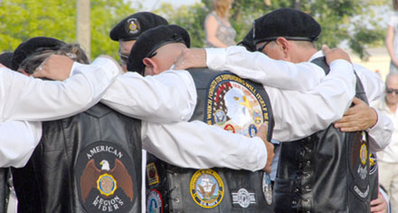

STUDENT INFORMATION:

_________________________________________________________
Name of Student

____________________________________________ ____________________________ __________ ______________
Mailing Address City State Zip

___________________________________________ ____________________________________________________________
Email Address Contact Phone Number

_______________________________________________ ________________________________________________________
Parent’s Name Parent’s Telephone Number

________________________________________ _______________________________ _______ _______________________
Home Mailing Address (if different from above) City State Zip

__________________________________________ _________________________________________ ___________________
High School Attending Principal’s Name Year Graduated

_________________________________________ ______________________________________________________________
Vocational School Planning to Attend Planned Degree/Vocation

________________________________________________________________________________________________________
Name and Relation of Veteran Family Member(s)

Non-academic activities and special interests (work experience, honors, athletics and other activities):
(Attach extra pages if necessary)

______________________________________________________________ _________________________
Signature of Student Date

