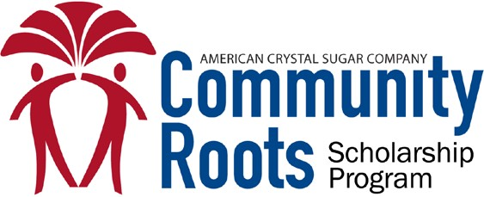

College and University Scholarship Application
Application deadline – April 15 $1,000 scholarship award
Complete and include this application cover sheet with other application materials when submitting to your counselor’s office or designated high school representative:
Applicant’s Name:
Address: City, State, & Zip:
Home Phone: Mobile Phone:
Email Address:
High School: College Attending:

American Crystal Sugar Company is a world-class agricultural cooperative that specializes in sugar and sugar-based products and by-products. Rooted in the Red River Valley of the North, American Crystal’s success is largely due to the people and communities within its core operating geography. For this reason, and many others, American Crystal is delighted to annually fund 50 scholarships for graduating seniors of area high schools attending colleges and universities.

General Scholarship Requirements:
The $1,000 scholarship funded by American Crystal is intended to be awarded to a well-rounded graduating high school senior pursuing post-secondary education in one or more of the following fields of study:
- Science
- Technology
- Engineering
- Mathematics
- Agriculture
Additional Requirements: In a separate document, please provide the following.
- Essay (see criteria below)
- Intended area of study
- Overall GPA (must have 2.5 or greater to be considered)
- Extra-curricular activities
- Community service &/or volunteer activities

Essay Information:
- Explain why you are deserving of an American Crystal scholarship.
- Briefly outline your college/university and career aspirations.
- Add additional information you feel may be relevant.

Recipient Selection:
Each area high school’s scholarship selection committee will review its applicants and select the winning recipient. One college/university scholarship is awarded per high school. American Crystal will issue scholarship award checks in the fall directly to the student, made payable to the student and the school they will be attending.

Scholarship applications must be submitted to your counselor’s office or designated high school representative.
Applications sent directly to American Crystal cannot be considered for scholarship awards.

